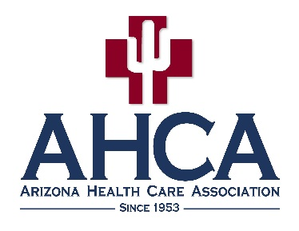

2023 Arizona Healthcare Executive Leaders Program

Explore Your Potential and Advance Your Career

Working in the profession of long term care is considered by some to be the career of the century – you are in the right place at the right time. This program will give you the opportunity to explore in depth your potential to grow and excel in your field through learning, dialogue, and networking. It will prepare you to advance within the management ranks of your company, and to serve on state and national boards and commissions. Participation in this leadership program will develop your voice in long term care, enhance your skill set, and distinguish you as a leader among your colleagues.

About the Program
The AHCA Arizona Healthcare Executive Leaders Program kicks off with an informative and interactive leadership training. Arizona Leaders will receive complimentary reading materials to help instill leadership qualities. Throughout this program, participants will have the opportunity to network with the AHCA Board of Directors, staff and key stakeholders through a variety of activities, including conference calls, Lobby Day events and a class graduation event at the Annual AHCA Convention and Expo in July.
Class members are selected by a committee made up of individuals from Arizona who have participated in AHCA/NCAL’s Future Leaders program and are leaders in their own right. Individuals may be nominated by an AHCA member center administrator, or they may self-nominate. Space for the AHCA Arizona Healthcare Executive Leaders Program is limited in class size and open to all Assisted Living and Skilled Nursing Center members, as well as one Business Associate Member.

What to Expect
Selected Arizona Leaders will receive pre-program reading materials and are expected to participate in all meetings/conference calls. You must be employed by an AHCA member in good standing and attend the Class Kickoff Training to be considered part of this program. Employment must remain at an AHCA member center throughout the course of the program. If conference calls or meetings are missed without correspondence with the class liaison, participants will not be allowed to complete the program.
Example Reading List (books will be provided)
- Good to Great, James C. Collins
- Leadership and Self Deception, The Arbinger Institute
- StrengthsFinder 2.0, Don Clifton / Gallup
- The Advantage, Patrick Lencioni
- The Truth About Employee Engagement, Patrick Lencioni

To Apply
Please fill out the attached application for the Class of 2023 and return it by Friday, November 11, 2022.

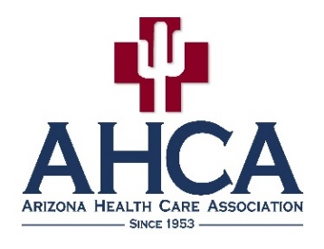

Arizona Healthcare Executive Leaders Program Class of 2023 Kickoff
Date: December 13, 2022
Location: AHCA office, 1440 E. Missouri Ave., Suite C-102, Phoenix, AZ 85014

Agenda:
December 13, 2022 (9:30 – 3:00pm)
- Orientation and supplies
- Overview of Program
- Leadership and Self Deception (conference call at 9:00 a.m.)
led by AHCA CEO Mark Parkinson
- What it Means to Be a Leader
- Volunteer Engagement
- Goal Setting
Fee: FREE - thanks to our generous sponsor!

Sponsor

This program is being brought to you by the generous sponsorship of:

2023 Arizona Healthcare Executive Leaders Program

The Arizona Health Care Association (AHCA) applauds those individuals who want to continue their career in long term care. In conjunction with the American Health Care Association/National Center for Assisted Living (AHCA/NCAL) Future Leaders Program, the AHCA Arizona Healthcare Executive Leaders Program works to develop professionals within the Association and Arizona’s long term care profession.

Application
To be considered for the Arizona Healthcare Executive Leaders Program, candidates must:
- Be employed in an AHCA member center or work at a business affiliate member company.
- Attend the AHCA Annual Convention and Expo in Phoenix, Arizona on July 25, 2023.
- Attend the AHCA/NCAL 74th Annual Convention and Expo in October 2023 (encouraged, but not mandatory).
- Pledge to continue to work in an AHCA member center for at least one year.
- Agree to complete the requisite one-year program. The first meeting is December 13, 2022.
- Provide your resume or biography.
- Describe in one page why you want to be in the Arizona Healthcare Executive Leaders Program.
- Have your supervisor provide a one-page recommendation letter.

Please provide the requested information and submit it to the AHCA office no later than Friday, November 11, 2022. Failure to provide ALL requested information will result in disqualification. Space for the Arizona Healthcare Executive Leaders Program is limited in class size and open to all Assisted Living and Skilled Nursing Center members, as well as one Business Associate Member.

When submitting by email, save the document to your computer, attach it with the additional items below and email to Fcaruso@azhca.org.

Name:

Address:

City: State: Zip: Cell:

Email (required): Shirt Size:

AHCA Member Center:

Position at Center: Length of Employment:

Nominated by: Supervisor’s Name:

Applicant’s Signature: Supervisor’s Signature:

Please submit the following items with this application:
- A resume or biography
- A one-page document about why you want to be part of this program
- A one-page recommendation letter from your supervisor

Completed application and all required materials must be emailed to Frank Caruso at fcaruso@azhca.org.

Thank you to our sponsor:

